**FireFlink Sign In**

If you are a registered user of FireFlink and have an existing account, you can easily access the platform by visiting<https://www.fireflink.com/>. Look for the Sign in button, which is clearly visible in the provided image.



After clicking on the Sign in button on the FireFlink website, users will be directed to a screen where they are prompted to enter their registered credentials.

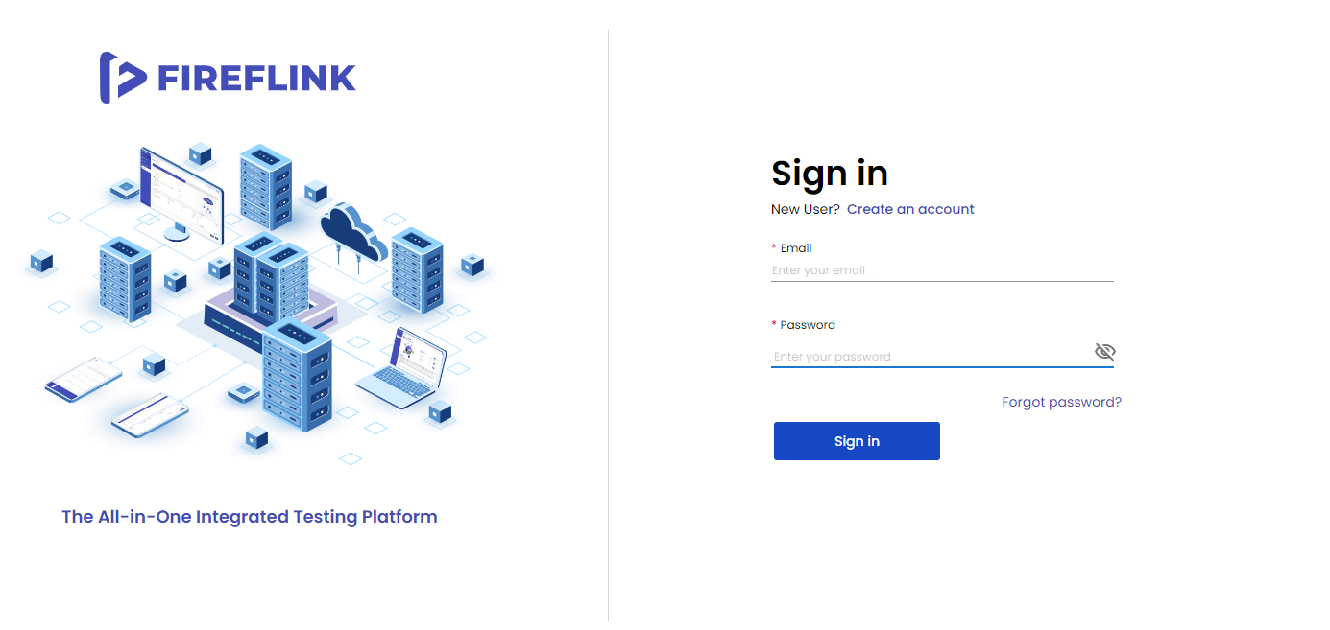

**Sign-in process**

After clicking on the "**Proceed to Sign in**" link, you will be directed to the FireFlink platform's **Sign-in page**. Then, enter your registered **email id and password** in the respective text fields, and click on the "**Sign-in**" button. This will lead you to the **Project Menu** of the All Projects level within the FireFlink platform. From there, you can create test automation projects for web, Android, and iOS applications, and carry out API (Web-Services) tests.

